EASE

Browser Settings

Table of Contents
I. Overview 3
II. What Browsers Work Best with EASE? 3
A. Google Chrome (Chrome) 3
B. Internet Explorer (IE) 3
C. Edge 3
D. Others 3
III. Troubleshooting and Information 3
A. Clear Browser Cache 4
B. Try a Different Browser 4
C. Modify Browser Settings 4
IV. Summary 4
V. Browser Settings 5
Google Chrome Settings for EASE: 5
Internet Explorer Settings for EASE: 8
Microsoft Edge Settings for EASE: 12

Browser Settings

Google Chrome Settings for EASE:
Ensure Cookies, Pop-ups and JavaScript are enabled. You can enable these settings or manage exceptions. If you manage exceptions, please add https://ease.arkansas.gov to the exception list for EASE and https://wg.ez.arkansas.gov for users that require access to BW Reports.
Within the Google Chrome Browser, click the icon in the top right corner and access the Settings Menu
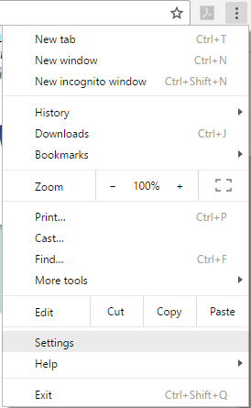

Search in the search bar provided at the top of the settings page or browse to the desired setting
Click Show advanced settings at the bottom of the Settings page
Under the Privacy section, choose Content Settings
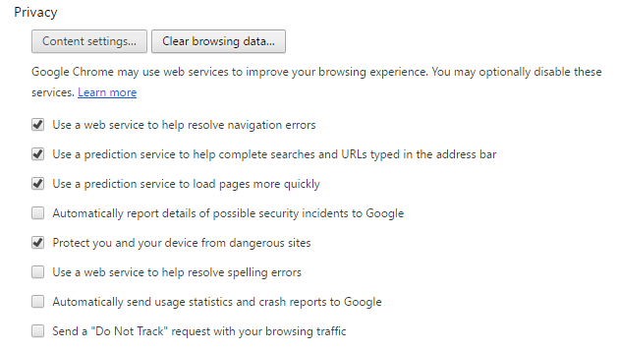
Under Cookies, Choose Allow local data to be set (recommended)
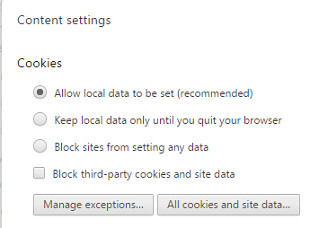

In the same Content Settings Menu, scroll to JavaScript and choose Allow all sites to run JavaScript (recommended)
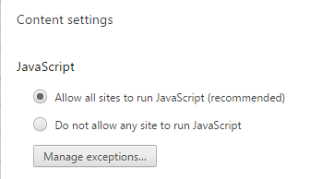
Then scroll to Pop-ups and either Allow all sites to show pop-ups
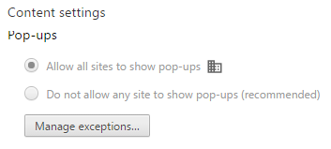
Click Done when you are finished making the changes and exit the settings screen.
<Back to Top>

Internet Explorer Settings for EASE:
Enable Pop-ups for https://ease.arkansas.gov
Within the Internet Explorer browser, click on the icon to access the Internet Options menu.
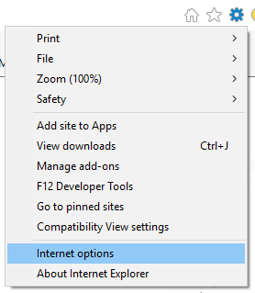

Within Internet Options, choose the Privacy Tab and under the Pop-Up Blocker section choose Settings.
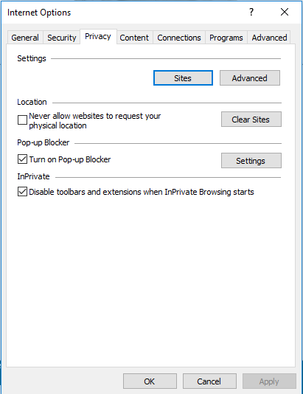

Ensure *.arkansas.gov is listed in the allowed sites. If it is not, input it into the Address of website to allow and click the Add button. Once you are done click Close.
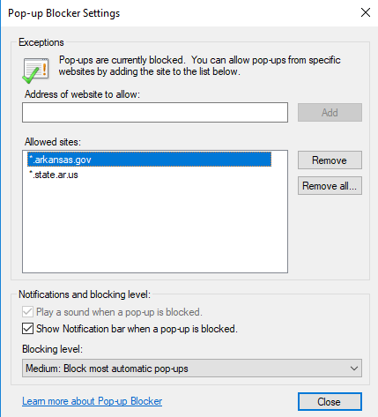

Change the Internet Zone Security settings
On the Internet Options menu again, choose the Security tab and select Internet and then custom level.
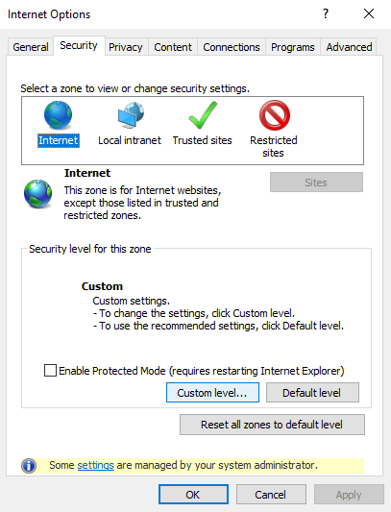
Scroll down to the Downloads section and ensure that File Download and Font Download are both set to enable.
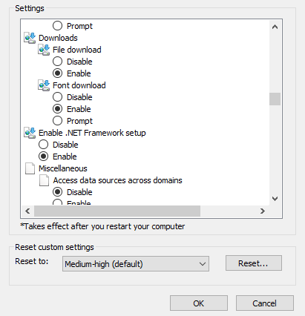

In the same Settings menu, scroll to Scripting and ensure Active Scripting and Scripting of Java Applets are enabled.
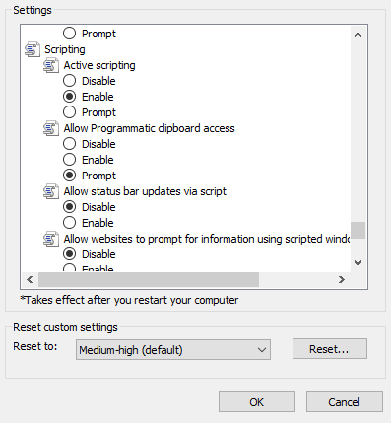
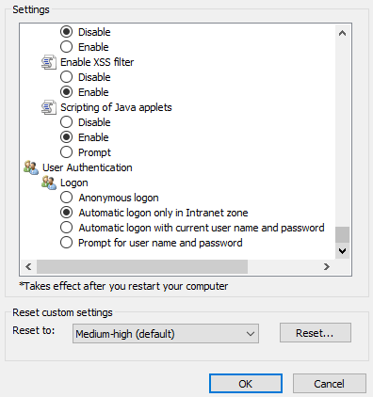

Save your changes and exit from the settings.
<Back to Top>

Microsoft Edge Settings for EASE:
Within the Microsoft Edge browser, Choose the icon and access the settings menu.
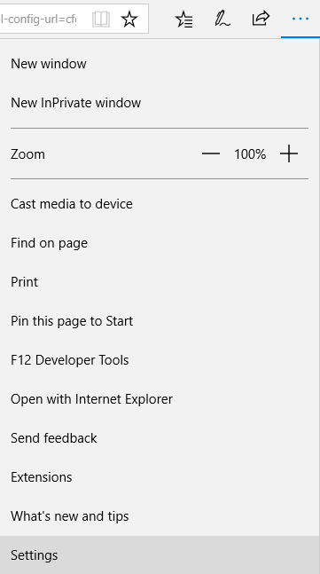

Scroll Down and choose Advanced Settings
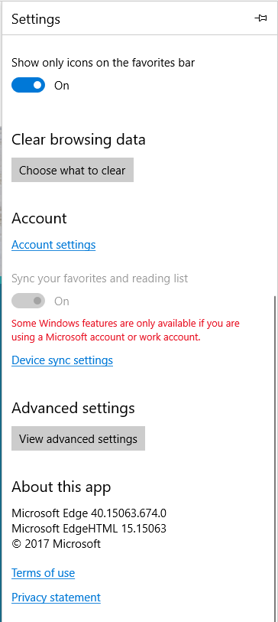

Please ensure that pop-ups are Allowed
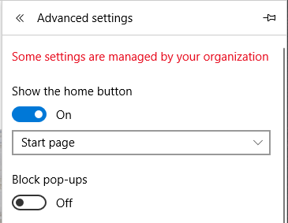

Ensure that you are not blocking any Cookies
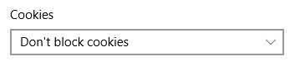
<Back to Top>

