Proposal for Arkansas State Fiscal Recovery Fund
Submitted by Department of Human Services
Titled: Proposal to Provide $10 million to Enhance Rural Hospital Services
August 29, 2022

Summary
In the aftermath of the COVID-19 pandemic, hospitals are struggling to maintain capacity to treat patients and protect the public and their staffs. The pandemic has disrupted the hospitals’ and nursing facilities’ abilities to maintain qualified staff at all levels within their organizations.

The Department of Human Services (DHS) proposes an additional $10 million in funding for services to benefit rural hospitals through the Arkansas Rural Health Partnership (AHRP). This assistance will enable rural hospitals to respond to the public health emergency related to COVID-19 and its negative impacts by addressing critical needs within these facilities and strengthening their operations through initiatives that will ensure that they continue to provide needed healthcare services. These funds may be used for costs related to COVID-19 between March 3, 2021, and December 31, 2024, that have not been reimbursed and are incurred for any of the purposes described below.

Applicant Description: Nobody understands the needs of rural hospitals like the leaders that work in rural hospitals. ARHP is a non-profit organization of 17 rural hospitals, two Federally Qualified Health Centers, and three medical schools where member rural hospitals are committed to remain autonomous for as long as they can. These hospitals understand that by partnering together and combining forces there is leverage in numbers giving them an advantage; especially when it comes to cutting operational costs, increasing access to healthcare services, improving quality of care, and addressing the needs of their patients and residents through population health initiatives, assistance services, and mental and behavioral health services and shared programs. ARHP offers its members multiple advantages; like purchasing power and discounts, contract negotiation, medical training, information technology, recruitment, and most recently, the formation of a Clinically Integrated Network. The organization works at keeping resources in rural areas and contracts with its member hospitals for services to support partnering hospitals. The organization is pursuing lowering costs for employee benefits, workers’ compensation, and medical malpractice insurance, along with business office procedures. This would be done in partnership with members only or possibly partnering with a larger health system. ARHP priorities have an emphasis on finding new approaches and organizational frameworks to improve health outcomes, control costs, increase the rural workforce, and improve population health. Education, financial assistance, and an experienced, educated, and competent support system to pursue the changes needed to survive would prevent our rural hospitals from closing. ARHP administration and leadership have vast knowledge and experience as healthcare administrators, hospital financial professionals, recognized rural health experts, grant writers, fundraisers in place. The organization is ready to provide immediate support to rural hospitals across the state.
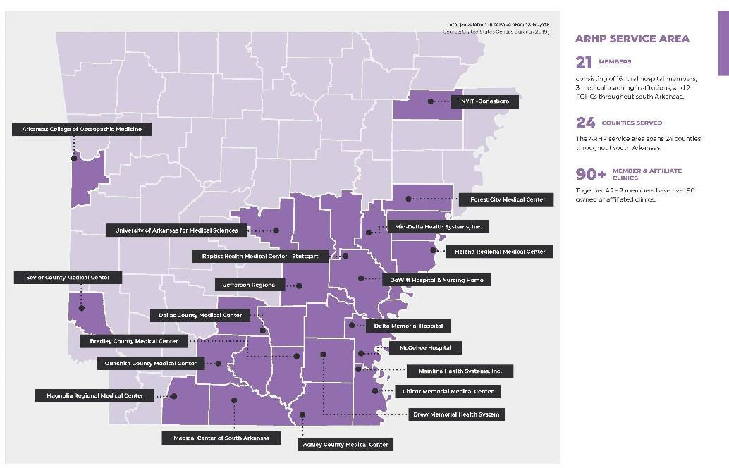

Purpose of Requested Funds: The intent of this request is to address the critical needs of Arkansas rural hospitals post COVID-19 by strengthening these organizations through initiatives that will ensure these hospitals continue to provide needed healthcare services by offering technical assistance to make in-depth health system enhancements to improve financial position and increase operational efficiencies, provide workforce recruitment, training, and retention needs, assist hospitals with integrating social services to address socio-economic challenges and enhance services, and integrating mental and behavioral health services to address the shortage of these services in rural Arkansas.

Number of Locations Served: 52 rural hospitals throughout Arkansas

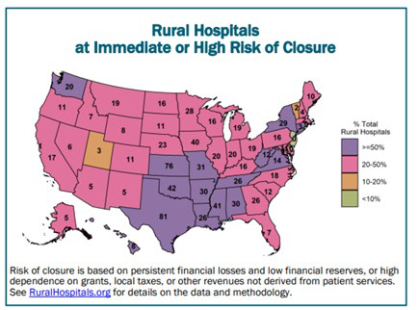
Need: More than 800 rural hospitals – 40% of all rural hospitals in the country – are at risk of closing in the near future. According to the Center for Healthcare Quality and Payment Reform, 61% of the rural hospitals in Arkansas have been identified as at risk of closure. Most of these are small rural hospitals that provide not only emergency care, inpatient care, and outpatient services, but also primary care, rehabilitation, and long-term care services for their communities. Moreover, most of the hospitals are in isolated communities where loss of the hospital could severely limit access to health care services. More than 2 million people could be directly harmed if these hospitals close, and people in all parts of the country could be affected through the impacts on workers in agriculture and other industries. These funds will be used in a long-term program to strengthen the rural hospitals, increase workforce in both numbers and quality, and improve the leadership skills that combined may prevent hospital closures and improve care in Arkansas.

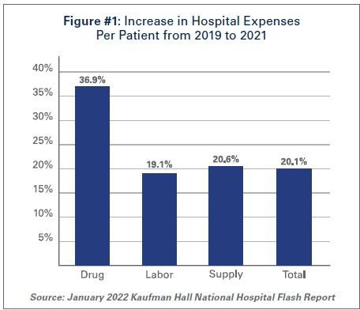
According to the American Hospital Association (AHA), hospitals and health systems have faced massive financial losses throughout the COVID-19 pandemic and continue to experience staffing shortages, rising expenses, and supply chain issues. Hospitals and health systems have been efficient in keeping up with COVID-19 surges since the onset of the pandemic. Facilities have expanded treatment capacity, hired additional staff, and maintained patient access to critical services and programs, AHA said. However, as a result, hospitals have experienced billions of dollars in losses. According to AHA, more than a third of hospitals have negative operating margins.

At the same time, the COVID-19 pandemic has revealed significant inequities in the availability of healthcare services and resources in rural Arkansas, as well as gaps in the availability of adequate mental and behavioral health services across the state. And the pandemic itself has exacerbated both the rural inequities and the need for additional capacity in mental and behavioral health services.

The drivers for the current overall hospital crisis are:

Cost Reimbursement. Hospitals are not being paid enough to cover the cost of delivering care to patients. Inadequate payments from both public and private health plans along with the inability of patients to pay their bills continues to be one of the concerns for hospitals.

Staffing Costs. According to data from the Bureau of Labor Statistics, hospital employment nationally is down approximately 100,000 from pre-pandemic levels. At the same time, hospital labor expenses per patient through 2021 were 19.1% higher than pre-pandemic levels in 2019. Labor costs account for more than 50% of hospitals’ total expenses. Therefore, even a slight increase in these costs can have significant impacts on a hospital’s total expenses and operating margins. Driving the growth in labor expenses has been an increased reliance on contract staff, especially contract nurses, who are integral members of the clinical team. In 2019, hospitals spent a median of 4.7% of their total nurse labor expenses for contract travel nurses, which skyrocketed to a median of 38.6% in January 2022. Contract staff agencies have increased the rates they bill hospitals significantly. In fact, hourly billing rates that hospitals pay staffing firms for contract employees increased 213% compared to pre-pandemic levels and led to a 62% profit margin for contract staff agencies, i.e., the difference between what the firms charge hospitals and what the firms pay the contract employees. (See Attachment A for cost analysis for Arkansas Rural Health Partnership hospitals conducted in August 2022).

Supply/Drug Costs. Drug expenses also increased dramatically, 36.9% on per patient bases, compared to pre-pandemic levels. As a share of non-labor expenses, drug expenses grew from approximately 8.2% in January 2019 to 10.6% in January 2022. Medical supply expenses grew 20.6% through the end of 2021, compared to pre-pandemic levels. When focusing on hospital departments most directly involved in care for COVID-19 patients − ICUs and respiratory care departments − medical supply expenses increased 31.5% and 22.3%, respectively, from pre-pandemic levels.

This is exacerbated in small, independent rural hospitals because:

Unlike most larger hospitals and those that are part of a larger health system that have been
experiencing financial losses, independent rural hospitals have reached the point where they no longer have sufficient financial reserves available to cover their losses and no method of paying their staff or creditors.

Private health plans pay small rural hospitals less than they pay larger hospitals for the same services, and Medicare Advantage plans appear to be among the worst payers at small rural hospitals. Most small rural hospitals operate one or more rural health clinics, and the low payments for primary care services from private payers are a major cause of losses at these hospitals.

Independent rural hospitals experience high costs for supplies, equipment, and contracted services because they do not have the volume to benefit from cost savings that are offered to larger healthcare systems.

There is a higher cost to recruiting and retaining healthcare providers, administration, and leadership to rural areas. Rural communities do not offer all the amenities of larger metropolitan areas. Without the volume of this workforce in rural communities, hospitals are having to pay the cost to keep the current workforce from leaving and, at the same time, pay staffing agencies the costs to ensure retention of services.

Proposed Services and Initiatives:

- Swing-bed Coordination: ARHP is proposing to increase the coordination and care of post- acute care patients across the state. This program will assist with moving patients within the statewide system to the appropriate level of care which makes the most economic sense for patients and hospitals. The proposed project will strengthen its relationship between small rural hospitals and larger hospitals by bringing a proven model from nationally recognized healthcare organizations (Allevant, developed by Mayo Clinic and Select Medical) into rural Arkansas. ARHP will focus efforts on marketing and communications for participating hospitals to assist them with communication and marketing to both larger hospitals and within their own communities. This project will improve the coordination and care of post-acute care patients across the state through the development of an online platform and hiring of a dedicated coordination team to organize and coordinate swing bed utilization between acute care and critical access hospitals. This will enhance care delivery for hospitals of every size across the state, while directly improving the financial viability of rural CAH hospitals. ARHP is currently implementing this project which is resulting in positive revenue for member Critical Access Hospitals. ($1.5 million for three years)

- On-site Healthcare Provider Simulation Training: ARHP is proposing to provide on-site simulation training to rural hospitals throughout rural Arkansas in partnership with UAMS Centers for Simulation Education to coordinate on-site COVID-response preparedness simulation training to rural hospital workers in rural hospitals in Arkansas. ARHP will work with rural hospitals throughout the proposed service area to coordinate three trainings a year at each site. By providing this training on-site, trainers/educators can work with hospital teams to assist them with facility preparation as well as procedures. Most importantly, the training can be facilitated in a team environment so participating healthcare workers can learn how to work together more effectively and efficiently in case of an emergency. ($2.7 million for three years)

- Expand Rural Clinical Nursing Training: To address the nursing shortage across the state, and especially in rural healthcare organizations, ARHP is proposing to expand its current task force to coordinate and increase the number of available nursing clinical rotations, in turn, increasing the number of rural trained nurses in the region in partnership with nursing schools throughout the state. The COVID-19 pandemic has exacerbated the problem as many nurses have been recruited out of the region by urban hospitals and/or travel nursing agencies that promise hefty sign-on bonuses and free housing. Nurses from the rural region are less likely to be enticed by these offers and leave the region, however rural healthcare organizations are struggling to fill vacant nursing positions. Although there are numerous nursing schools throughout the state with students from rural communities, there are too few available clinical rotations in rural areas to increase the number of (predominantly local) nurses trained. The project will address the need for formalized collaborative efforts, locally available nurse preceptors, and the creation of additional clinical rotation thus increasing the capacity for nursing schools located in rural areas to expand their admissions and provide students that are unable to leave their rural community with an opportunity to pursue a career in nursing. ($1 million over three years)

- Integration of Mental and Behavioral Health Services: Rural hospitals are struggling with revenue while mental and behavioral health services are almost non-existent in rural Arkansas. ARHP is proposing to assist rural hospitals in transitioning empty hospital beds into mental and behavioral health inpatient and outpatient service beds and integrating telehealth services as an approach to address the shortage of mental and behavioral health providers. The COVID-19 pandemic created an even more dire need for additional mental and behavioral health services. By providing these services in the rural hospital setting, patients can receive care close to home and the hospital benefits from the revenue from these services. There is still a significant resource need to enable rural hospitals to assemble the infrastructure and resources needed to implement mental and behavioral health services. ($2.8 million for three years)

- Integration of Social Determinants of Health: ARHP is proposing to increase the capacity of identifying and addressing social determinants of health (SDOH) in small rural communities in partnership with rural hospitals in Arkansas. Identifying and addressing SDOH such as housing, education, nutrition, and access to services can have a significant influence on health outcomes. This connection is particularly important for individuals receiving behavioral or mental health services, and SDOH must be addressed to better ensure positive health outcomes as a result of the integration of mental and behavioral health services discussed above. This connection has also proven critically important in addressing the ongoing social effects of the COVID-19 pandemic and the rural inequities exposed by the pandemic. These workers will be able to assist with insurance enrollment (Medicare, traditional Medicaid, and ARHome), prescription assistance, social needs screening, telehealth and telemonitoring support, food assistance, patient navigation services, COVID testing and vaccinations, and health events working together with member healthcare organizations and providers. These assistance services will result in cost savings to patients, revenue to healthcare providers, and healthier patients. These services have been critical during the COVID pandemic when patients were struggling to find resources. ($2 million for three years)

Restrictions on funds:
The recipient of funds will be required to attest that these are necessary expenditures due to the public health emergency with respect to COVID-19 and that none of these funds are used to duplicate or supplant funding from any other source of payment.

Process and Procedures for Payment:
Payment will be issued by the Arkansas Department of Finance & Administration (DFA) following approval of this proposal. Expenses covered under this program may not be reimbursed under any other federal or state program.

